**Structured Training Program: Networking**

**Week 1**

*Module 1: Communication Fundamentals & Module 2: Network Architecture and Network Protocol*

1. Consider a case, a folder has multiple files and how would you copy it to the machine destination path.

Answer:

Using cp command: cp command with ‘r’ flag can be used for recursively coping file from one directory to another

cmd: cp -r path/of/src-dir path/of/dst-dir

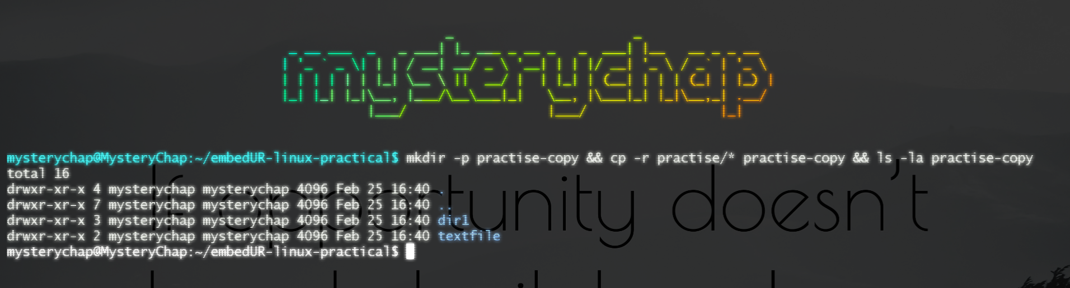

Using scp command: uses SSH to securely copy files across machines. cp is for local copy or transfer of file. scp is for copying file across machine. Similar to cp we can use -r flag in scp flag also to recursively copy files from the folder.

cmd: scp -r /path/of/src-dir path/of/dst-dir

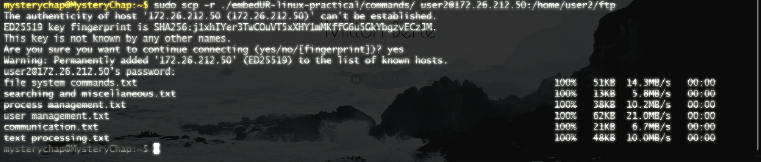

2. Host an FTP and SFTP server and try PUT and GET opertions.

Answer:

2.1) Configuring Trivial FTP server

a) Install the Very Secure File Transfer Protocol Daemon (vsftp) from apt package manager

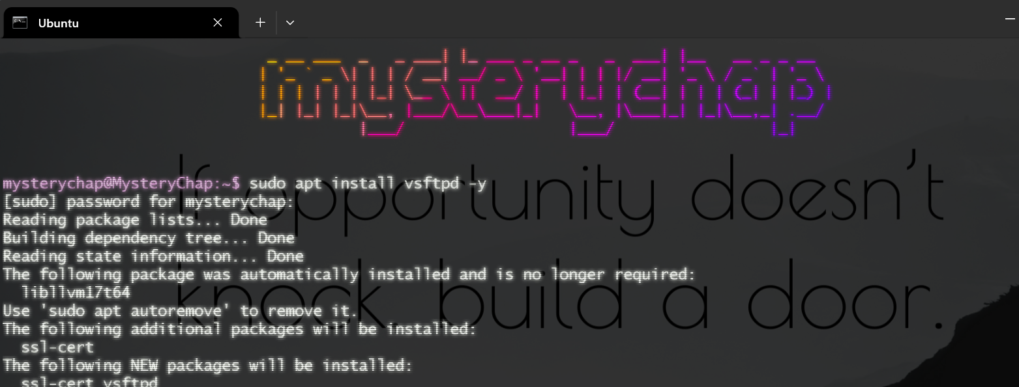

b) Start the daemon and enable it

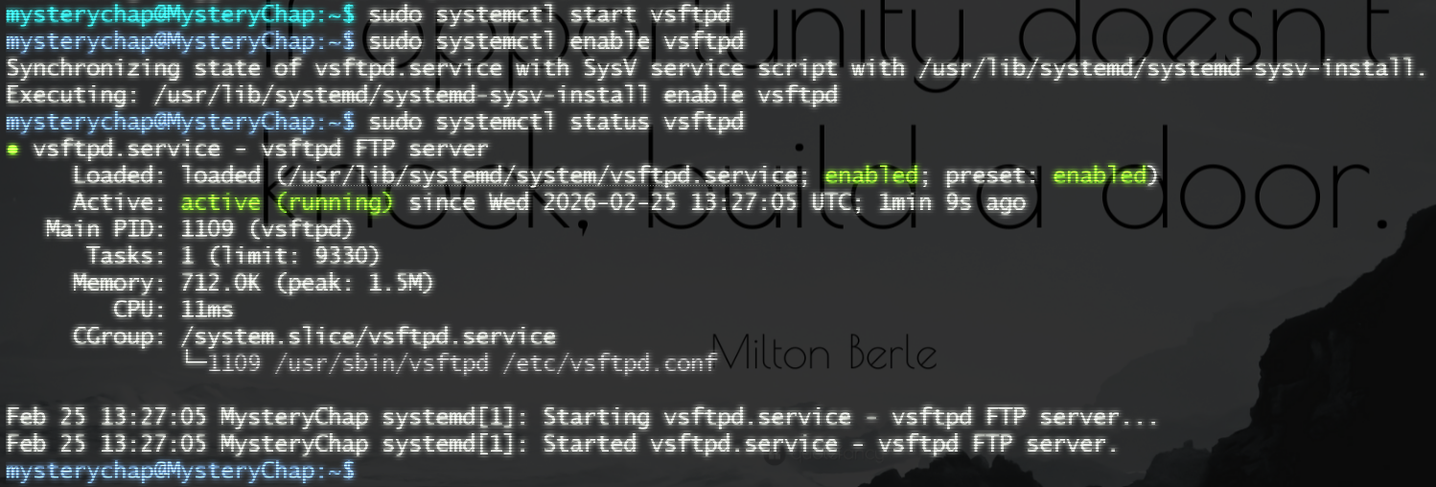

c) Create a backup of the original configuration file and configure the file



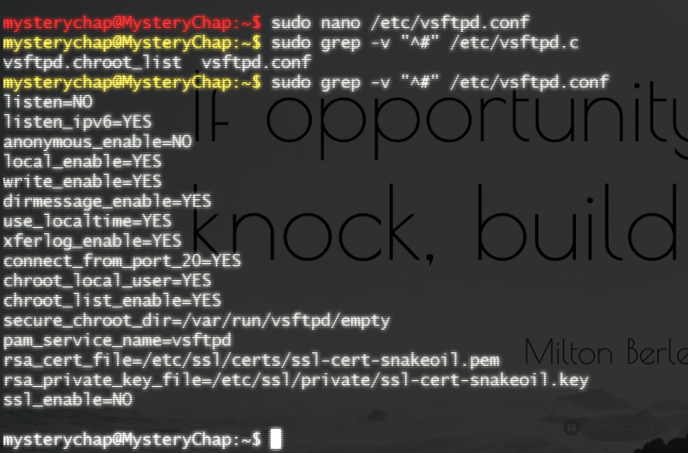

d) create a user particularly for FTP access

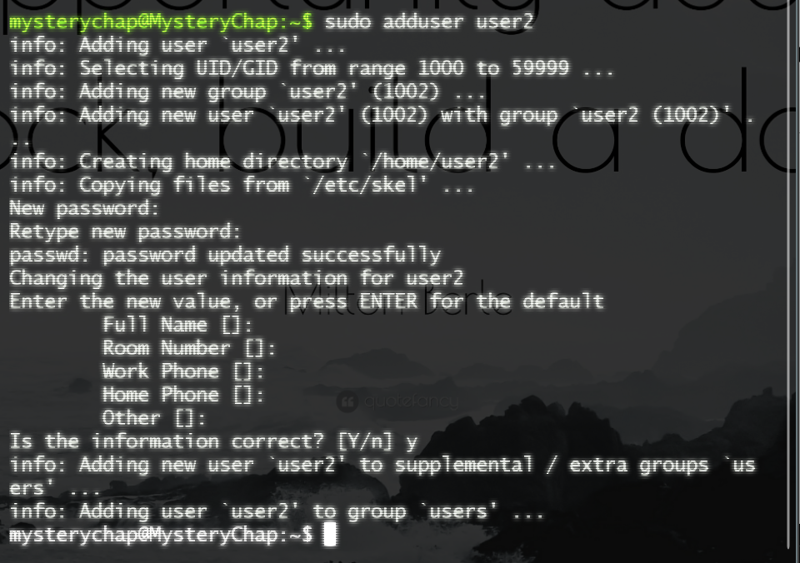

e) Create required directory for the FTP aceess. Since we have enables the chroot option in the configuration we have to change the home directory ownership to root. No other user must access that creating a security jail and have a folder accessable by ftp user.



f) Create files for transfer.

 

g) Connect to the my machine with its IP address and login with the ftp username and password (check before remote machine connection)

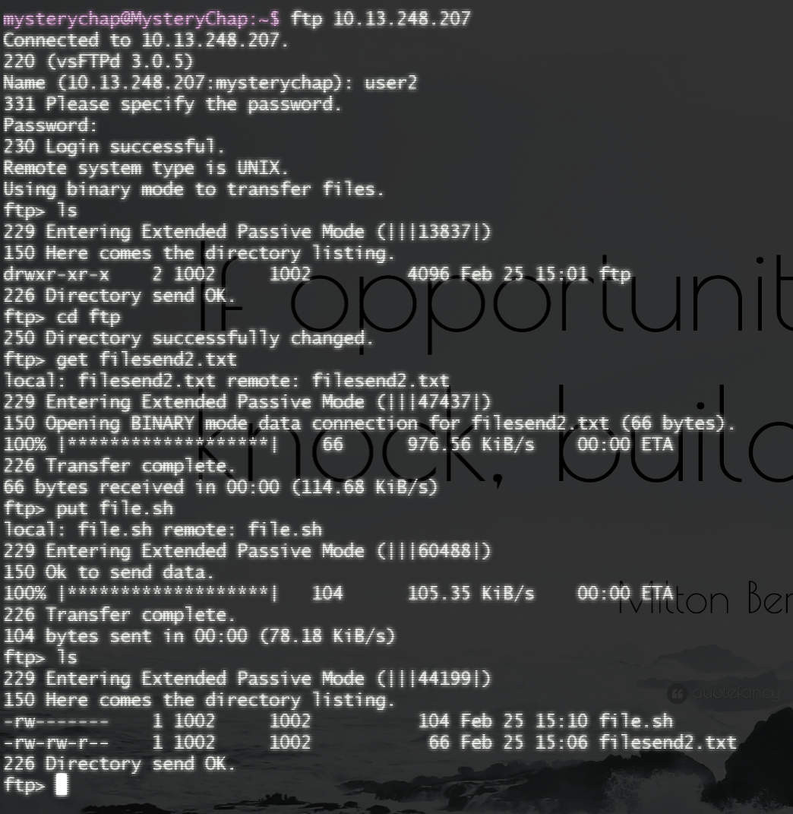

h) Remote Machine FTP: (Set firewall rules in case of windows system or use ufw to allow ports in case of linux on both the system or turn of the firewall temporarily till the configuration is complete)

1. Check connectivity using ping (make sure they are in the same subnet or a static-ip with DNS resolution)

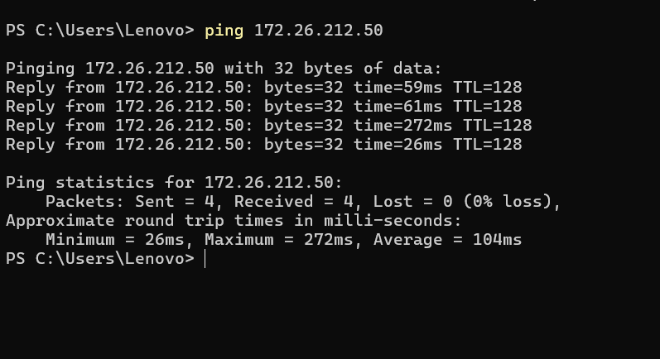

1. Since the remote system was a windows’ one I used WinSCP application to connect to file server.

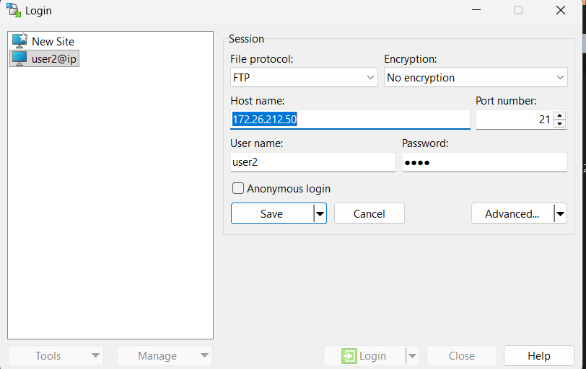

1. Connection established and file transferred

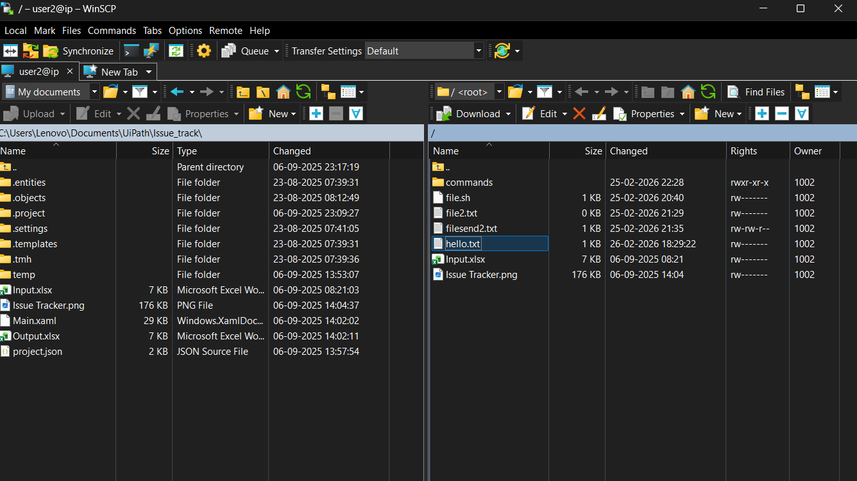

1. I have also captured the packet and saw the complete connection flow

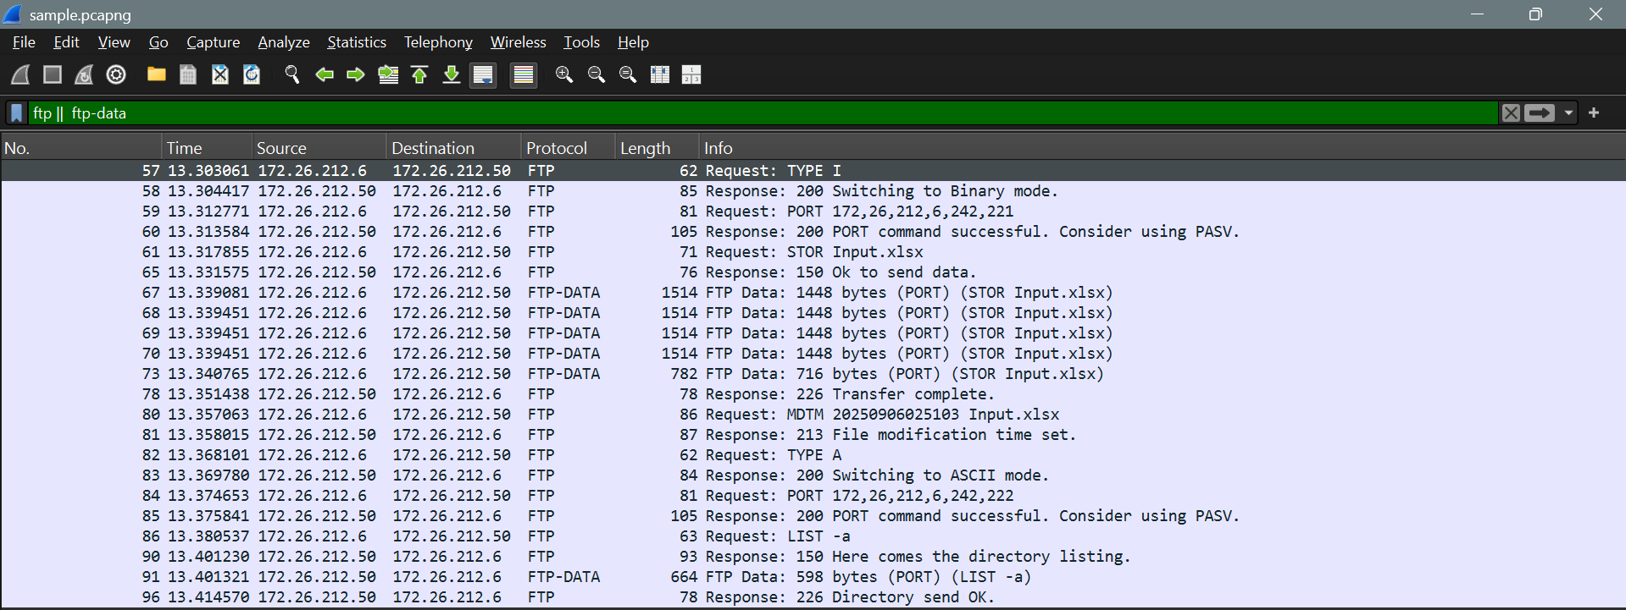

2.2) Configuring SFTP server that uses SSH in the Application layer along with FTP for encryption.

i) Install the openssh-server (this will install the additional required packages automatically)

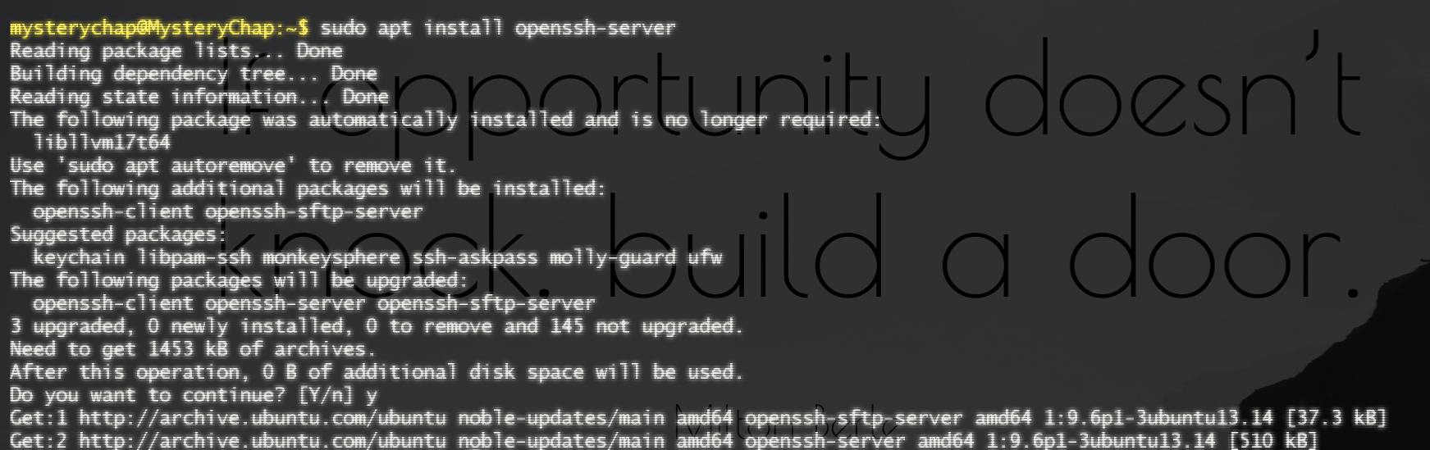

j) Now connect with the command ‘sftp’, send and receive the required files with put & get commands

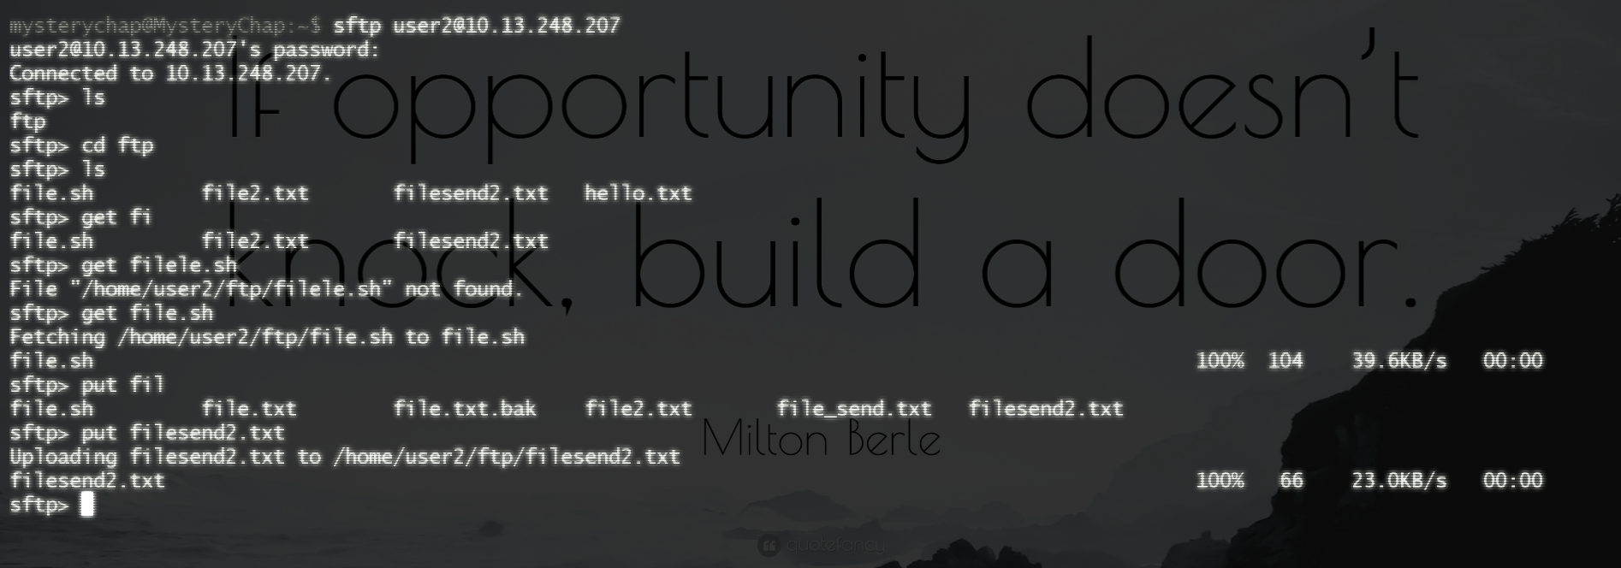

k) Remote Machine FTP: (Set inbound rules and outbound rules in case of windows system or use ufw to allow ports in case of linux on both the system or turn of the firewall temporarily till the configuration is complete)

1. Similarly use WinSCP with SFTP option

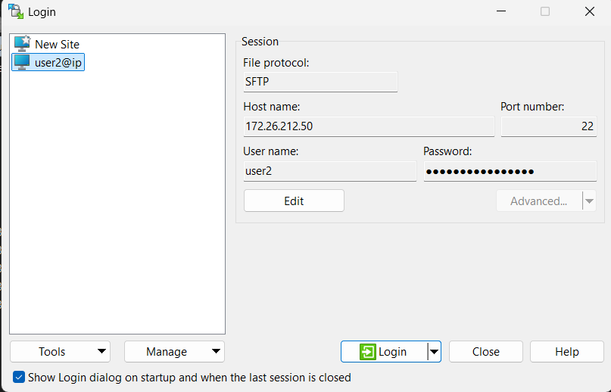

2. Connection established and file transferred

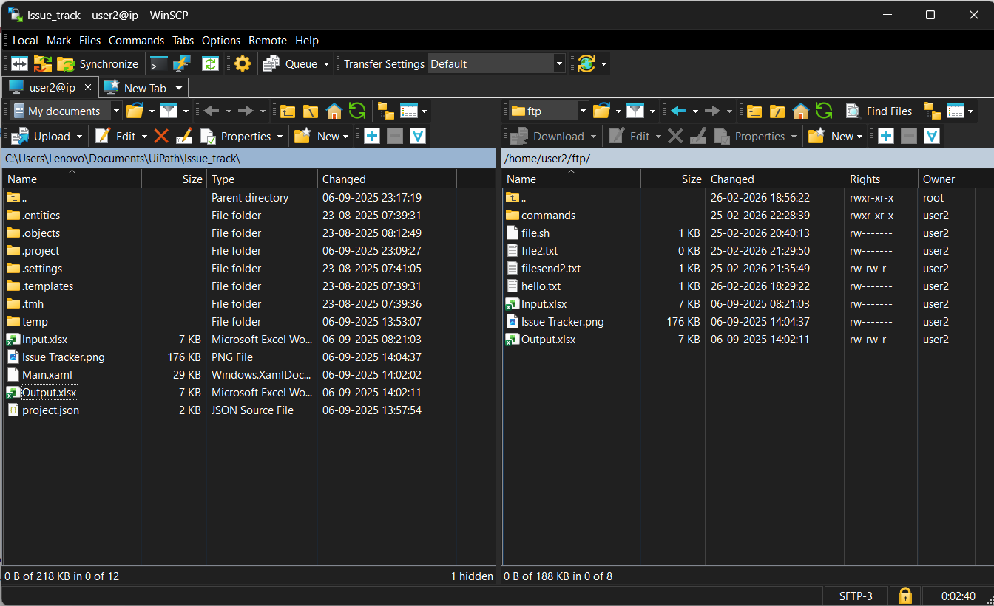

3. I have captured the packets for analysis for SFTP since it used SSH for connection instead of plain FTP and TCP for transfer the protocol filed didn’t specify FTP as its application layer protocol

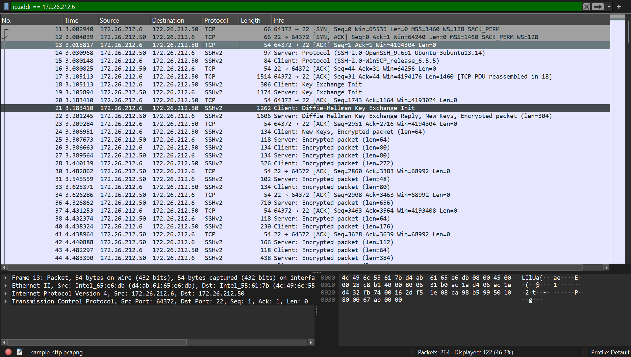

3. Explore with Wireshark/TCP-dump/Cisco Packet Tracer tools and learn about packet filters.

*Packet filter with Wireshark (We can filter a packer by protocol/IP/port)*

1. Using protocol

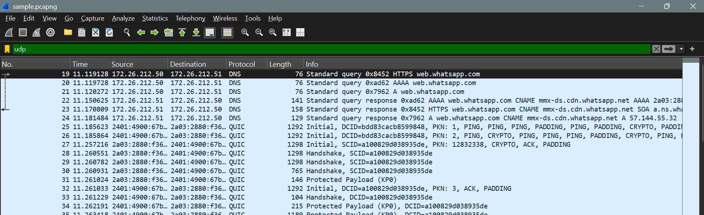

1. Using ip address

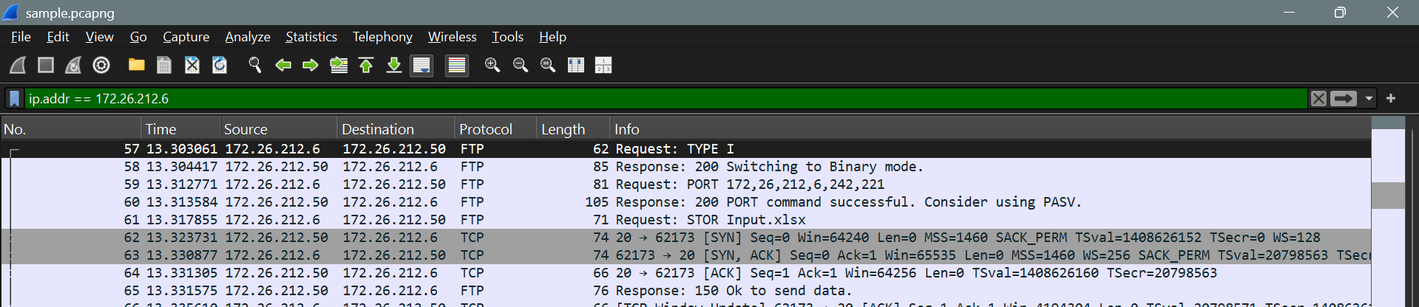

1. Using port

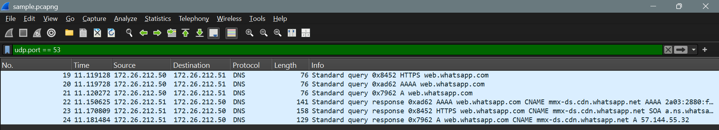

*Packet Filter with TCPDump command (similarly we can filter by IP/Port/Protocol)*

1. Using protocol

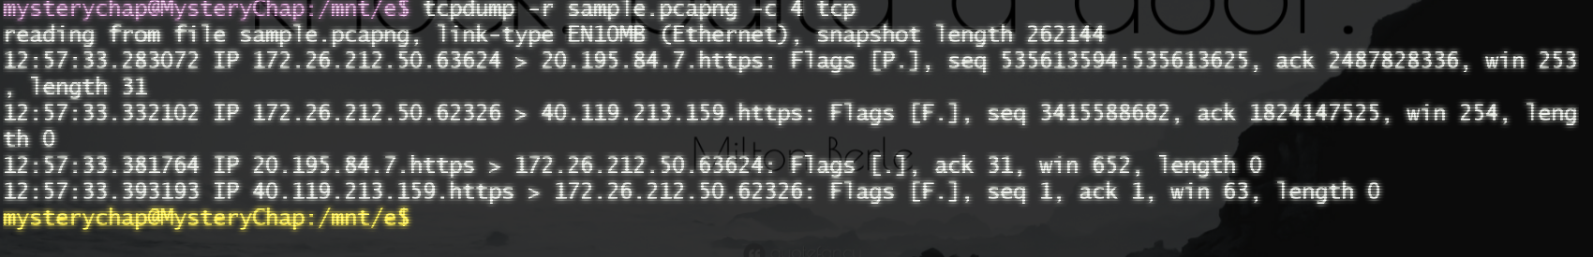

1. Using ip address

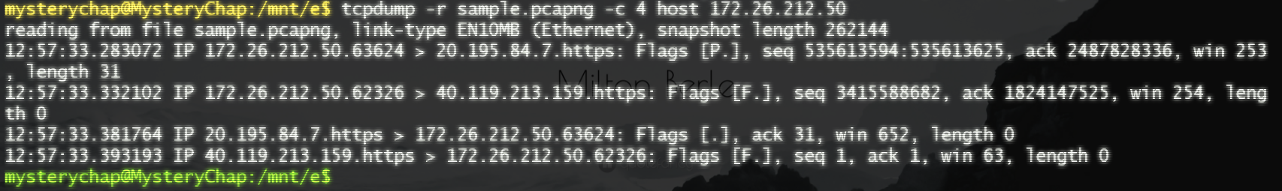

1. Using port



4. Understand linux utility commands like ping, arp (Understand each param from ifconfig output)

ping:

Ping is a Linux utility command that comes with the inet tools. It is used to check network connectivity between two devices or between a device and a domain name. Ping works using ICMP (Internet Control Message Protocol). It sends ICMP Echo Request packets to the destination and waits for ICMP Echo Reply packets in response. If replies are received (ICMP Echo Response), it confirms that the destination is reachable and the network connection is working properly. Additionally it measures the RTT and packet loss.

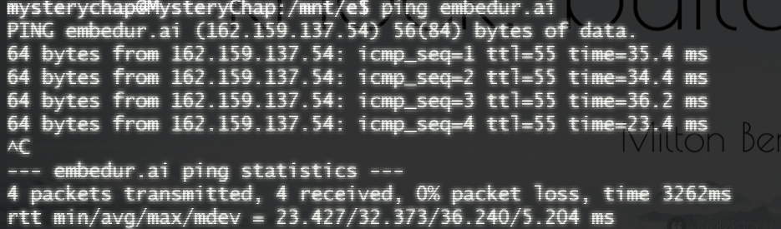

arp (Address Resolution Protocol)

ARP is used to map an IP address to a physical MAC address in a local network. It maintains a table called the ARP cache, which stores the IP-to-MAC address mappings. It broadcasts the ARP request packet to all device in the network and once received the destination device unicast the ARP response packet to the sender with its MAC attached and commonly used among the devices in the same subnet.

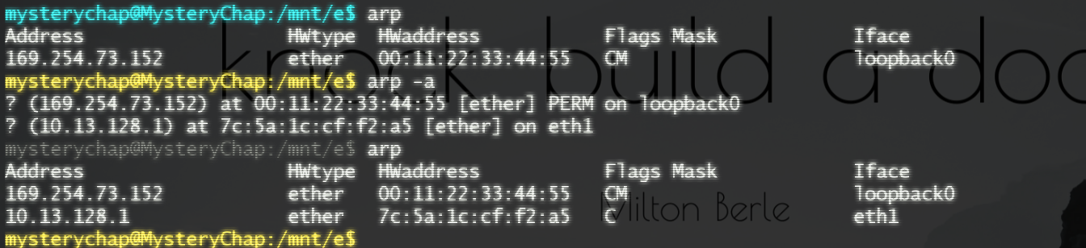

ifconfig:

ifconfig displays and manages network interface configuration and statistics. We can also create a network interface or turn on or off the existing interface with ifconfig.

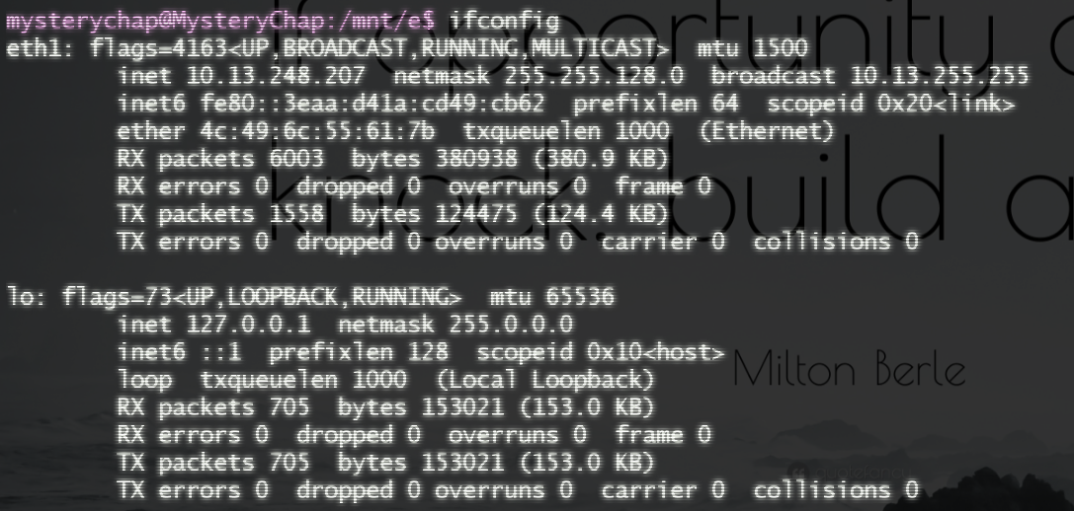

5. Understand what happens when duplicate IPs configured in a network.

When duplicate IPs are configured in a network the following things happen

1. Packet loss and unstable network behaviour.
2. ARP resolution conflicts due to duplicate MAC-to-IP mappings.